Rapid Cycling & Mixed States As “Waves”
Anxiety, mood and energy, all waving up and down, sometimes with each other, sometimes one going off without the others: a total mess, right? Not quite. It’s a bit technical but the pictures tell it well, so skim through those and see if you get it.
The term affective instability means, roughly, unstable mood and energy. People with such instability have big changes in their mood, or energy, or creativity over time. They may have easy tearfulness, such as crying over a commercial on TV. They may have extreme episodes of anger, often over a minor event. They can sometimes have inappropriate “mirth” — laughing too loud or too long, or being too giddy or goofy — although, isn’t it interesting, that’s not a problem I hear about much!

You see, according to the current official rules of diagnosis (the DSM-5), “mixed states” are still very narrowly defined: multiple manic symptoms and multiple depressive symptoms at the same time. But patients do have other combinations of depression and hypomania, or mania — not just the two worst phases together. And they do have cycles shorter than 4 days.

Symptoms vary at different rates
Here the green curve represents mood, the red curve represents energy, and the black curve represents “intellect” (speed of thought, creativity, ability to connect ideas).
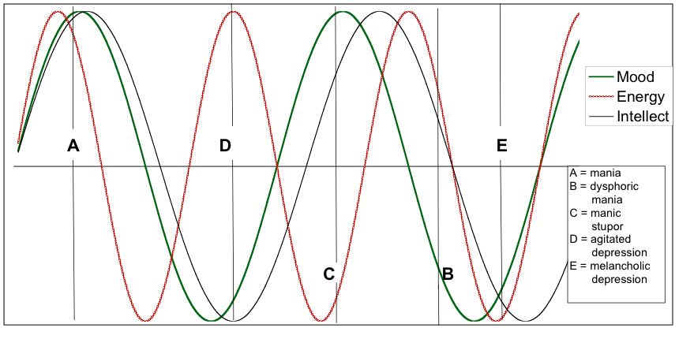

As you can see, if they all go up together — and far enough “up” — this would be what is commonly called a manic or hypomanic episode, as shown at point A on the graph.
If they all come down together, far enough, that would be an episode of “major depression”, as shown at point B.
But now we can see how “agitated depression” could be part of a bipolar problem, when the energy curve is up while the others are down, as at point D.
Point C represents an unusual combination usually recognized only on inpatient psychiatry units, when a person is agitated yet hardly moves, so-called “manic stupor”. But imagine what a milder version of this would look like: the person would know she needed to get moving, indeed she would be thinking of many things she needed to be doing, and she might really want (in a very powerful way) to be doing them, and yet her body would refuse to go along.
Point B represents another very important combination we psychiatrists see commonly: the energy wave is up, but the mood wave is down (in this case, the timing is such that the intellect wave is up too, but not as high as the energy — yet there are many combinations, as you’ll see in a moment). This could be called “dysphoric mania”: energized, as in a usual manic phase, but mood is very negative.

Now consider the rate at which the different waves vary.

Rapid cycling: 4 per year or 4 per week?
Bipolar disorder is supposed to have phases lasting at least 4 days. Shorter than that, and it doesn’t fit the official model. But the shorter versions are seen so often they have their own names.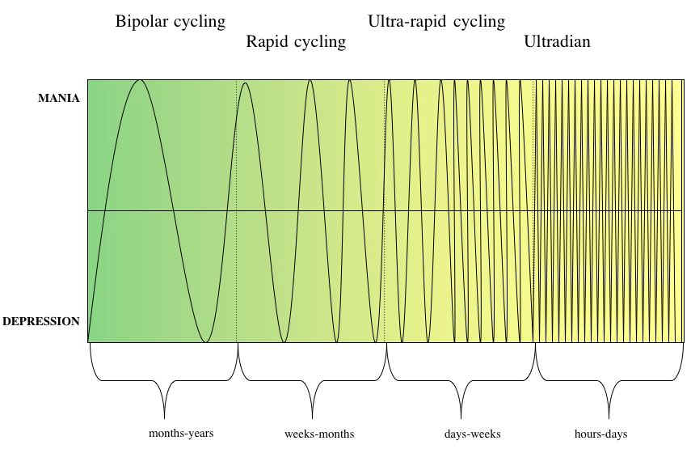

4 per week? sure: here’s a clear case of cycling every other day. Admittedly, when the “cycles” get so short there are multiple moods in a day, the condition gets hard to distinguish from “normal emotions” — normal reactions to events that last a few minutes or even close to an hour or so. If such rapid emotional shifts are extreme, most psychiatrists start to think of a different diagnosis: borderline personality disorder. But here’s the point: combine the first two graphs to see how mixed states explain experience, next.

Continuous, continually varying symptoms
Many people with Bipolar II do not have the “well intervals”, in between periods of having symptoms, that are often spoken of in websites and books about Bipolar I. This leaves them somewhat puzzled. Do they really have “bipolar disorder?” Why, they never really have “episodes”, let alone “manic” episodes.
Yet as the following graph shows, a rapid cycling of the individual symptoms, at different rates, can create a varying pattern of nearly continuous symptoms. Instead of having identifiable “episodes”, this person has almost constantly shifting symptom phases that blend into one another.
